NAME __________________________________per. _______
Real or Fake?

Have you ever found something on the internet that seemed real but wasn’t? What was it and what made it seem real? _______________________________________________________________________________________________
_____________________________________________________________________________________________________________________
Finding reliable background information is necessary for scientists. With all the information available, it is important to know what is accurate and true and what is inaccurate and false.
You will research the following animals. One of these animals is fictitious – that’s means it is not real! Your job is to research each animal and decide which 2 are real and which one is made up. Try to find multiple sources that are reliable for each animal. Good luck!

*If you already know about these animals, please don’t tell the others. It spoils the fun.

1- Aye Aye 2 - Pacific Northwest Tree Octopus 3 - Dumbo Octopus
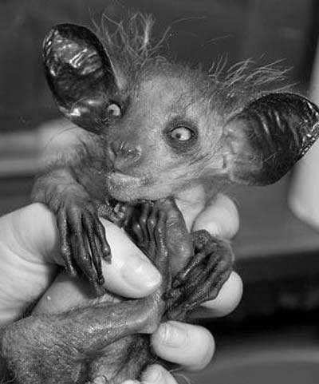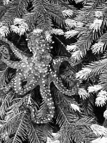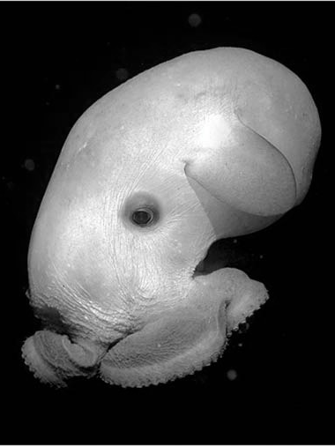

As you research these animals, you’ll need to find at least 5 facts about each and list the websites where you found your information. GOOGLE is NOT a source. It takes you to sources!
1
Animal’s common name ___________________________________________________________
Animal’s scientific name ___________________________________________________________
5 facts (where does it live? What does it eat? How big does it get? Is it common or rare? Is it dangerous? How does it reproduce? Is it endangered? etc…) ____________________________________________________________________________________________________________________________________________________________________________________________________________________________________________________________________________________________________________________________________________________________________________________________________________________________________________________________________________________
Sources of Information (list at least 2 website addresses where you got information) __________________________________________________________________________________________________________________________________________________________________________________________________________________________________________
Animal’s common name ___________________________________________________________
2
Animal’s scientific name ___________________________________________________________
5 facts (where does it live? What does it eat? How big does it get? Is it common or rare? Is it dangerous? How does it reproduce? Is it endangered? etc…) ____________________________________________________________________________________________________________________________________________________________________________________________________________________________________________________________________________________________________________________________________________________________________________________________________________________________________________________________________________________
Sources of Information (list at least 2 website addresses where you got information)
__________________________________________________________________________________________________________________________________________________________________________________________________________________________________________
3
Animal’s common name ___________________________________________________________
Animal’s scientific name ___________________________________________________________
5 facts (where does it live? What does it eat? How big does it get? Is it common or rare? Is it dangerous? How does it reproduce? Is it endangered? etc…) ____________________________________________________________________________________________________________________________________________________________________________________________________________________________________________________________________________________________________________________________________________________________________________________________________________________________________________________________________________________
Sources of Information (list at least 2 website addresses where you got information)
__________________________________________________________________________________________________________________________________________________________________________________________________________________________________________
ANALYSIS QUESTIONS:
1. Based on the information you found, which animal is fictitious? ________________________________________
2. Explain how you know. ______________________________________________________________________________________ _____________________________________________________________________________________________________________________
3. Why is it important for you to make sure your background information is reliable and accurate?
__________________________________________________________________________________________________________________________________________________________________________________________________________________________________________
4. On the site that listed information about the fictitious animal, what tactics were used to make the information look accurate? _____________________________________________________________________________________
_____________________________________________________________________________________________________________________
_____________________________________________________________________________________________________________________

