NAME______________________________3
DATE____________PER________
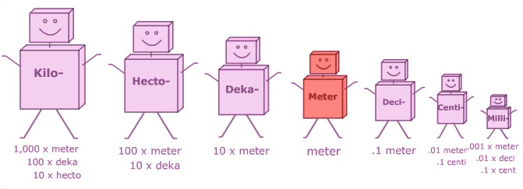

1. Label the above prefix figures with the correct number amount.

2. ___________________ is the distance between two points.

3. Which tools do scientists use to measure length?
___________________________________________ (mm, cm, m)

4. Which is larger a millimeter or a kilometer? __________________

5. Which is smaller a decimeter or a decameter? _________________

6. What is the basic unit of measurement for length? _____________

7. Which unit of measurement is the distance between your two fingers as
close as they could be without touching? _______________
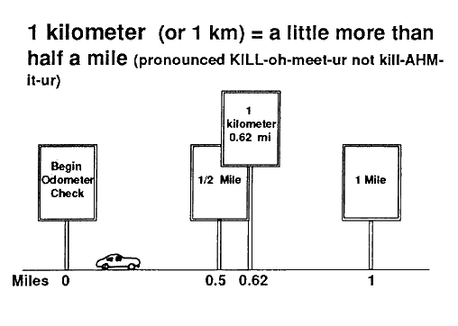
8. Which is longer a mile or a kilometer?

9. Which is longer an inch or a centimeter?

10. Which is longer a meter or a yard?

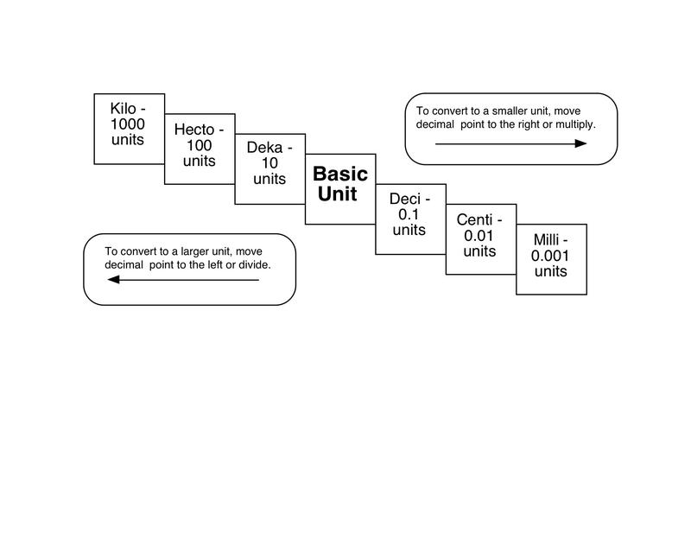

Write a Comparisons, Examples, or Objects that are
close to the following units of lengt
 | Kilo-meter | Hecto-  meter | Deka-meter | METER | Deci-  Meter | Centi-  Meter | Milli-  Meter
Comparison #1 | A little over half a mile | Length of football field | Length or width of a bedroom | Baseball Bat | Length of new Pencil | Width of paper clip | Thickness of finger nail
Comparison #2

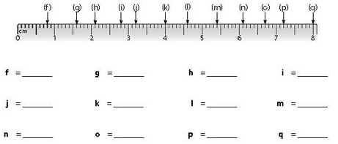

NAME_______________________4
DATE____________PER_________

Part 1 Mass of Solids

1. _____________________ is the amount of matter in an object.

2. What tool do scientist use to measure mass?
_______________________________________ or the TBB

3. What is the unit of measurement for mass? ___________________

4. How to use a Triple Beam Balance:
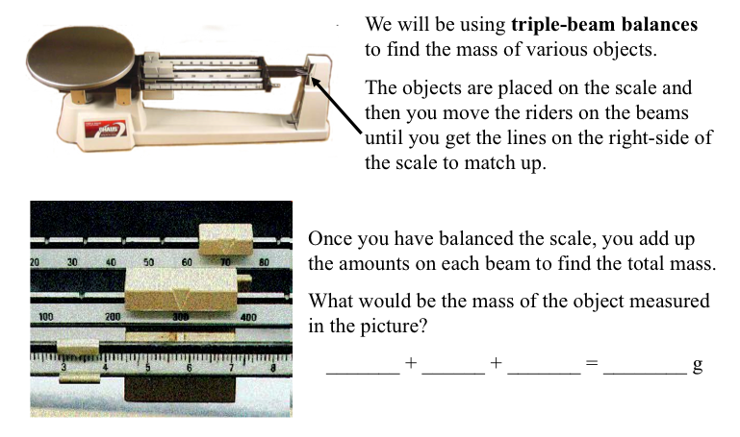

Part 2 Mass of LIQUIDS
MASS OF LIQUID =
Mass of CONTAINER & LIQUID (MINUS) Mass of EMPTY CONTAINER

5. Draw a picture that illustrates the formula for finding the mass of a
liquid below.

Part 3 Measuring Mass Lab Practice
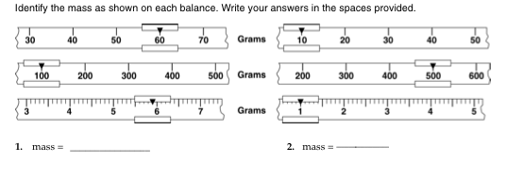
1.

2. Find the mass of the following solids using a Triple Beam Balance:
Object | Mass (grams)
1. Wooden Block
2. Scissors
3. Dice
4. Wooden Ruler

3. Find the mass of the following liquids using a Triple Beam Balance and Graduated Cylinder:
Liquid | STEP 1 Mass of Graduated Cylinder (g) | STEP 2 Mass of Graduated Cylinder & Liquid (g) | STEP 3  Mass of Container & Liquid  MINUS  Mass of Container  (grams)
Liquid 1

Liquid 2

VOLUME NAME______________________5
DATE____________PER_________
Part 1 Measuring Volume PPT
1. _________________ is the amount of space an object takes up.

2. Volume of a LIquid
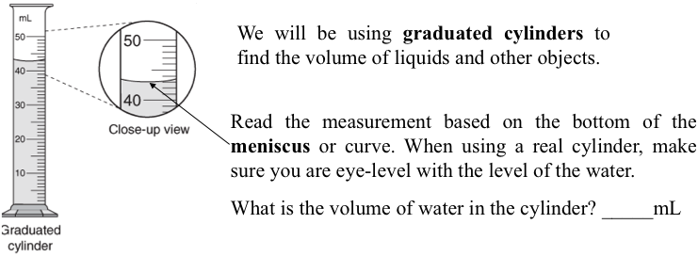

3. What tools do scientists use to measure Volume of
a. Liquid: _________________________ (mL)
b. Solid:___________________________(cm³)

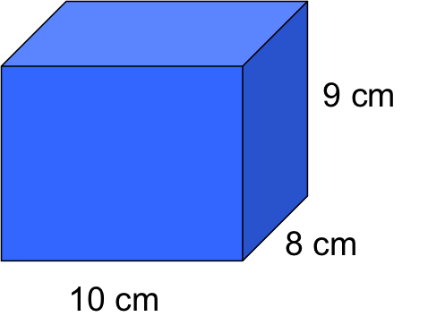
4. Volume of a Regular Shaped Object (cube)
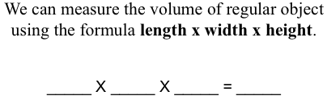

5. Volume of Irregular Shaped Object (rock) Formula =
Volume of Object & ________ MINUS Volume of Object
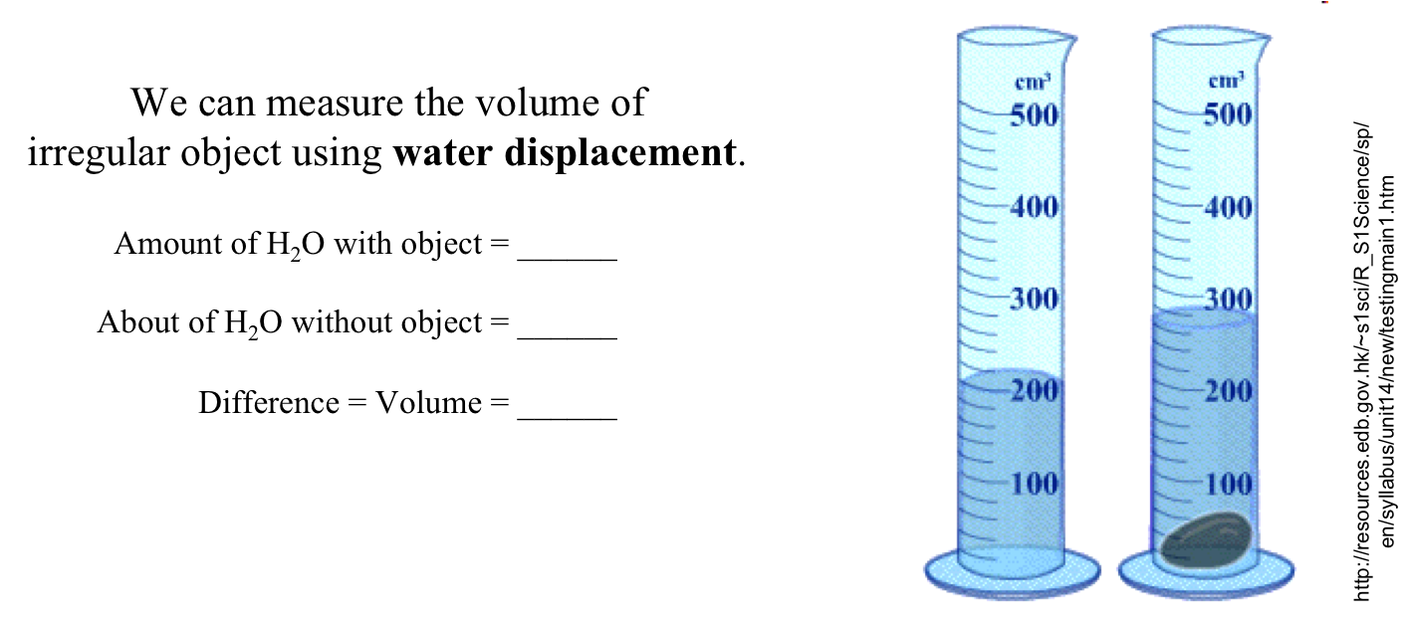

Part 2 Measuring Volume Lab Practice
- What is the volume of each liquid in the first four cylinders? Record below.
- The volume of the liquid in cylinder 5 before the rock was placed inside was 25 mL.
- What is the volume of the liquid & rock?______________
- What is the volume of just the rock? ________________
- What is the name of the process used to find the volume of an irregular shaped object> ___________________________
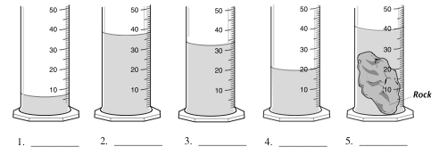

3. Find the volume of 3 marbles by filling a graduated cylinder to 20 ml. Drop the marbles in and see how much the water rises – this is the volume of the marbles. Complete the table below.
WATER DISPLACEMENT
A) Volume of water before  adding marbles | B) Volume of water after  adding 3 marbles | C) Volume of 3 Marbles  B minus A

4. What is the volume of the large dice . Use formula: Volume = L x W x H

_________ x _________ x _________ = __________cm³

5. What is the volume of the small paper cut?
*Hint: a. fill the cup all the way to the top with water.
b. pour the water from the cup into a cylinder to measure the
amount of water.
c. Volume of CUP = _____________mL

