Structure and Function Name _____________________________9
Date _________________ Per. _________

- Explain why the task of cutting the paper with a paperclip wasn’t realistic.

- Screwdrivers are different shapes to fit different screws. Can you think of any other tools that have specific structure/shape for their specific functions? List a tool and explain why its shape/structure allows it to function.

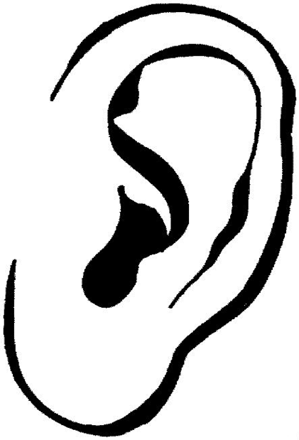

- Explain how the shape of the outer ear helps it to function.

- Explain how the shape of the wing allows the bird to fly.

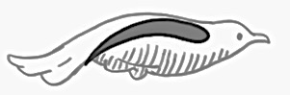
- Other than the wing shape, what structures help a bird to fly?

- Explain why hollow bones would be beneficial for birds.

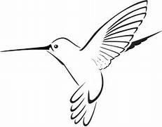
- Bird’s beaks are suited to the food they eat. Explain why a humming bird has a long skinny beak.

- Group Discussion and Assignment. With your group, discuss and list at least 3 other examples of structure and function (at least 1 living and 1 non-living).
1.

2.

3.

- Draw one example from above (showing structure/function)

Mr. Wood… Structure & Function

1. Compare and explain how you were able to walk with the wooden splint and without the wooden splint.
With Splint Without Splint

2. Referring to #1, which was easier and WHY???

3. What evidence shows how the structure of the knee supports the function of the knee.

4. In your groups, DISCUSS and SHARE 3 examples (living and/or non-living) similar to the FUNCTION of the knee.
1.

2.

3.

5. Is the knee a system? Use Evidence to EXPLAIN why or why not!

