NAME ____________________________8
MATTER & ENERGY
DATE _______________ PER __________

- What is the ultimate source of all ENERGY on Earth? __________________________________________________________
- Once on earth where does the ENERGY go? ____________________________________________________________________
- What is the ultimate fate of all EMERGY? _______________________________________________________________________

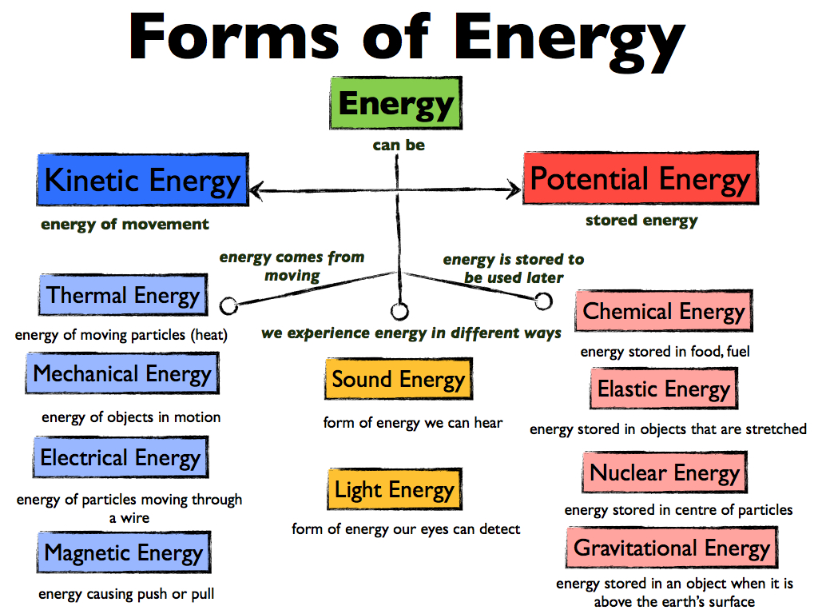
LIST AN EXAMPLE NEXT TO EACH FORM OF ENERGY.

ENERGY & MATTER ROTATION

Station | Answers
Station 1: Lava Lamp
Station 2: Cars
Station 3: Alka-Seltzer
Station 4: Falling Objects
Station 5: Silly Soil
Station 6: Changing Waters
Station 7: Plants vs Sun
Station 8: Flowing Power

