NAME __________________ 7
Systems & System Models
DATE ___________ PER ______

SYSTEM RULES… | EXAMPLES
1. A SYSYTEM is anything made of components (parts) that work together to form a whole.
2. Each component of a system can itself be described as its own system.
3. A system is very different from its components.
4. All components are connected to other components.
5. Systems have FLOW (input & output)

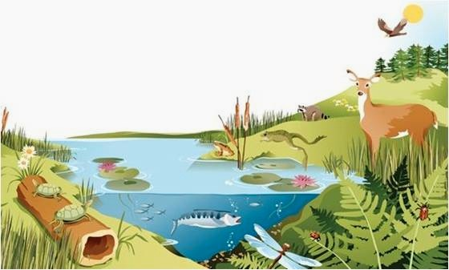

ANSWER THE FOLLOWING QUESTIONS USING THE PICTURE ABOVE.

- Why is this picture an example of a SYSTEM? Evidence!
___________________________________________________________________________________________________________

- What are some of the components (parts) of this Eco-system?
___________________________________________________________________________________________________________

- List & explain how components (parts) of the Eco- system are connected/depend on each other.
1___________________________________________________________________________________________________________
2___________________________________________________________________________________________________________

- List a part of the Eco-system and explain how it is its own smaller system.
___________________________________________________________________________________________________________

- What are the input and or outputs in this system? Label the arrows on the picture.
___________________________________________________________________________________________________________
SYSTEM MODELS
- A system model is typically a 3-D structure that scientist and engineers build to help them better __________________________ what something looks like and how it __________________________.

Solar System Scale Model Activity Questions

1. List 2 things you learned about the solar system from constructing and studying this system model.
1. _____________________________________________________________________________________________
2. _____________________________________________________________________________________________

2. What does the length of the string in the model represent?
________________________________________________________________________________________________
________________________________________________________________________________________________

3. How can you move the string to represent the actual orbit of the planets? Explain
________________________________________________________________________________________________
________________________________________________________________________________________________

4. What is accurate about this system model?
________________________________________________________________________________________________
________________________________________________________________________________________________

5. What are the limits of this model?
________________________________________________________________________________________________
________________________________________________________________________________________________

6. List & Explain 3 Science & Engineering Practices that you used in this activity.
1_______________________________________________________________________________________________
________________________________________________________________________________________________
2_______________________________________________________________________________________________
________________________________________________________________________________________________
3_______________________________________________________________________________________________
________________________________________________________________________________________________

GROUP # _______________________
CLASS PERIOD _________________
Solar System Scale Model Activity

Purpose: Construct a scale solar system model using beads and string.

Materials per Group:
5 meters of string 10 beads meter stick marker calculator

Background Information:
Astronomers refer to the distance from the sun to the Earth as one “astronomical unit” or AU. This will provide an easy way to calculate the distances of the other planets from the sun and build a scale model with the correct relative distances.
1 Astronomical Unit (AU) = Approximately 150 million kilometers or 93 million miles.
THE SCALE-FACTOR FOR THIS MODEL IS 10 CENTIMETERS PER 1 AU

Procedures:
- Complete the distance chart by multiplying each AU distance by the scale-factor of 10 cm per 1 AU.
- Start your scale model by cutting 5 meters of string.
- Tie the first or largest bead to one end of the string using a double knot.
- Using the calculated distances in centimeters, measure the distance from the sun on the string to the first planet (Mercury). Mark this distance on the string with a marker.
- Tie a colored bead in place for the first planet (Mercury).
- Repeat steps 4 & 5 for the rest of the planets.
- Answer the analysis questions on packet paper #7!

Data Table

Object | AU | Scale Value  (Centimeters) | Bead Color
Sun | 0.0 AU
Mercury | 0.4 AU
Venus | 0.7 AU
Earth | 1.0 AU
Mars | 1.5 AU
Jupiter | 5.2 AU
Saturn | 9.6 AU
Uranus | 19.2 AU
Neptune | 30.0 AU
Pluto | 39.5 AU

