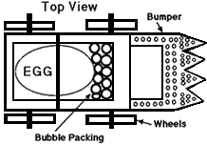
EGGSEPERT COLLISION CHALLENGE

Purpose:
- Students will use the Engineering Design Process to build a car that will protect a passenger (raw egg) from breaking when a force is applied such as a collision.

Background:
How do people survive major car crashes at higher speeds? Engineers and Scientists use Newton’s Laws to reduce the damage to both cars and people during crashes. During this project, you will work as a team of Engineers to create a sturdy, fast, and safe car to protect your passenger (raw egg) from getting damaged during the collision.

Rules:
- Cars must be able to roll down the provided ramp with a raw egg as a passenger and must survive collisions against a solid barrier at the end of the ramp.
- Teams must stay within their budget and only use the provided items. Wheels MUST be made from lifesaver mints.
- Each team’s car must meet the following dimensions in order to race:
  - Height: 6 inch high Maximum, no minimum
  - Length: 10 Inch length Maximum, no minimum
  - Width: 6 inch Width Maximum, no minimum
  - Weight: No Maximum or Minimum
  - # of Wheels: Minimum of 3
- Each team will need to keep their supplies and racecar in the provided container before and after class. You are responsible for the safety of your car and your supplies!!
- On race day, cars will be released down the ramp by a member of your team. Ramps may be used for test trials during class leading up to the race.
- On race day, the egg must be “healthy” and unbroken/cracked after impact.

Grading:
Project Assignments | Point Value
Individual Student Hand-out | 30 points
Group Hand-out | 20 points
Teacher Graded Participation | 20
Team Mates Grades Participation | 10
Photo of Car | 5
Race Day Car Performance | 15
Total Points Possible | 100

Race Day Car Performance Rubric
- EXTRA CREDIT will be given to the teams with the 1) fastest car, 2) most creative and 3)sturdiest/safest car.

Sturdiness
5 points | Car makes it down the ramp in 1 piece with no extra force needed
3 points | Car loses one part, but still makes it down the ramp with no extra force needed.
1 point | Car loses 2 parts, makes it down the ramp and/or needs extra force
0 points | Car loses more than 2 parts and does not make it down the ramp without extra force
Safety
5 points | The egg passenger remains safe and has no cracks
3 points | The egg passenger remains safe, but has small cracks upon collision
1 point | The egg passenger is hurt with many cracks or leaks
0 point | The egg passenger didn’t make it
Aesthetics
5 points | The car looks awesome!!!!  - Neat in appearance  - Catchy design
3 points | The car looks good but is very generic
1 point | The car looks rushed and sloppy
Extra Credit
TOTAL
(15 points possible)

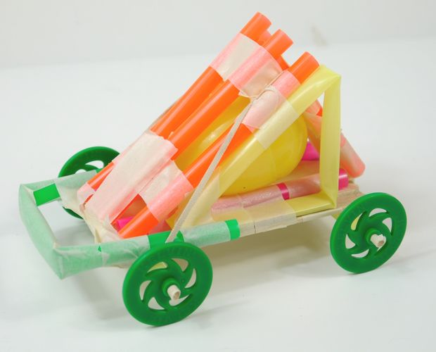
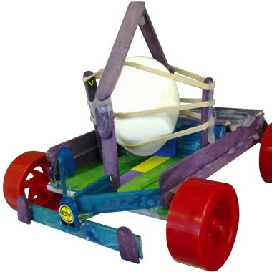

Name: _________________________
Class Period __________
The Eggspert Collision Challenge
Individual Student Hand-out (30 Points)
Engineering Design Process:
Step One: Identify the Problem (describe the challenge to be solved).
_________________________________________________________________________________________________________________________
_________________________________________________________________________________________________________________________
_________________________________________________________________________________________________________________________

Step Two: Explore (Research what others have done. Discover what materials are available.)

Step Three: Design (Use your knowledge and creativity to come up with many solutions. Chose one idea and draw or make a model of it.)
List Materials you will use and explain at least 2 designs.
Materials: _____________________________________________________________________________________________________________
_________________________________________________________________________________________________________________________
Design 1_______________________________________________________________________________________________________________
_________________________________________________________________________________________________________________________
_________________________________________________________________________________________________________________________
Design 2_______________________________________________________________________________________________________________
_________________________________________________________________________________________________________________________
_________________________________________________________________________________________________________________________
*Car Blueprint (Drawing of your car) will be completed as a team on the Team Hand-out.

Step Four: Create (Make your Solution.)
- Fill out the Budget Table on your Team Hand-out.
- Obtain your materials.
- Begin Building. Good Luck and Be SAFE (caution: hot glue gun)

Step Five: Try It Out (Test your solution.)
1. You may use the ramp for test trials.

Step Six: Make it Better (Evaluate how the solution worked and think how to improve your design.)
After testing your prototype, list problems and possible solutions.
_________________________________________________________________________________________________________________________
_________________________________________________________________________________________________________________________
_________________________________________________________________________________________________________________________
_________________________________________________________________________________________________________________________

Racing Day DATA Collecting:
Car Name  (Group #) | Mass of Car (grams) | Force  Ramp Height (meters) | Distance  (meters) | Time  (seconds) | Did the Egg survive?
1
2
3
4
5
6
7
8
Racing Day DATA Collecting continued:

Car Name  (Group #) | Mass of Car (grams) | Force  Ramp Height (meters) | Distance  (meters) | Time  (seconds) | Did the Egg survive?
1
2
3
4
5
6
7
8

Project Questions/Analysis:

1. Explain how increasing the height of the ramp affected the car. What is your evidence to support your answer? _______________________________________________________________________________________________________________
_________________________________________________________________________________________________________________________
_________________________________________________________________________________________________________________________

2. Did the cars with a greater mass travel faster or slower? Explain factors that would affect this.
_________________________________________________________________________________________________________________________
_________________________________________________________________________________________________________________________
_________________________________________________________________________________________________________________________

3. Explain an example of how each Law of Motion was used/applied in this project.

# Law of Inertia _____________________________________________________________________________________________________
_________________________________________________________________________________________________________________________
_________________________________________________________________________________________________________________________

#2 Law of Acceleration ______________________________________________________________________________________________
_________________________________________________________________________________________________________________________
_________________________________________________________________________________________________________________________

#3 Law of Action & Reaction ________________________________________________________________________________________
_________________________________________________________________________________________________________________________
_________________________________________________________________________________________________________________________

4. List and explain a Cross Cutting Concept used in this project. ________________________________________________
_________________________________________________________________________________________________________________________
_________________________________________________________________________________________________________________________
_________________________________________________________________________________________________________________________

5. List and explain a Science and Engineering Practice used in this project.
_________________________________________________________________________________________________________________________
_________________________________________________________________________________________________________________________
_________________________________________________________________________________________________________________________

Car Blueprint (Drawing of your car)
- Your drawing should take up most of the space provided below.
- Car must be drawn accurately to scale
- All car parts must be labeled
- Car Name: __________________________________________________
- Approval be Mrs. Allred before you begin building. __________________________________________________
f. Dimensions:

Height (Max 6”)
Length (Max 10”)
Width (Max 6”)
Mass (grams)

Names: ______________________________________________________________________________________ Class Period: __________
_______________________________________________________________________________________________ Group #: ______________

The Eggspert Collision Challenge
Team Hand-out (20 points)
Budget
Your Team’s Budget is $100

Item | Cost per item | Number Purchased | Total Cost if Item
Life Saver | $5
Sheet of Cardboard | $20
Pipe Cleaner | $5
Craft Stick | $10
Straw | $5
Masking Tape | $10 per 12 inches
Card Stock | $10 per sheet
Paper Clip | $5
Rubber Band | $10
Skewer | $10
Poster Putty | $5 per square
Paper | $5 per sheet
Cotton rounds | $10 per round
TOTAL SPENT

