GROUP NAMES ______________
Bird BEAK Challenge!!!
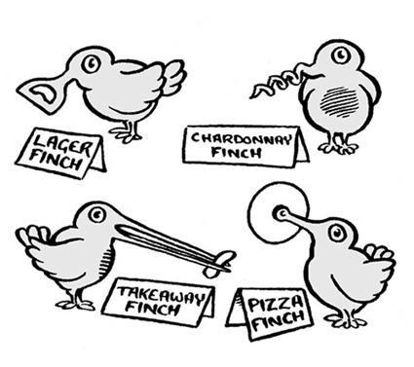
____________________________________________________
__________________________
__________________________

CLASS PERIOD _________

OBJECTIVE:
Your challenge is to design and build a bird beak that can pick up the largest variety and greatest amount of food. As a group you will take your “BEAK” and make your way through the 8 stations, recording how many of each item you were able to pick up in the allotted time.
RULES:
1. You can only use the materials provided for your group to build your beak.
2. You must Draw your BEAK to scale with measurements.
3. Teacher sign off BEFORE you start to build.

BEAK Drawing & Measurements

Teacher Sign Off ___________________________
Name _________________Per _____
BIRD BEAK CHALLENGE
COLLECT DATA:
Rotate through the 8 stations. At each station write the name of the food source. Collect as much of the food as possible in 10 seconds. Count and Record the # of Food Items Collected at each station.
FOOD TYPE | # of Food Items Collected in 10 seconds
Station 1 =
Station 2 =
Station 3 =
Station 4 =
Station 5 =
Station 6 =
Station 7 =
Station 8 =

BAR GRAPH:
Make a bar graph showing the data collected above. Remember TAILS!

DATA ANALYSIS:
1. Which Food Source is your BEAK the BEST adapted for? Provide Evidence or proof for your answer!

2. Describe the habitat your bird would be best adapted to? Explain WHY!

3. Was your BEAK the best for all food types? WHY or WHY NOT?

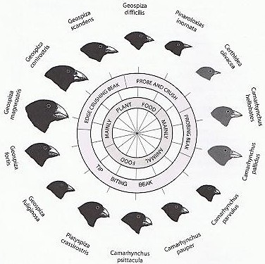

This chart shows some of the finches Darwin encountered on the Galapagos Islands. Different beak shapes are suited to different food sources.

4. What sort of a beak would be necessary for breaking open large nuts and or seeds? WHY?

5. What sort of beak would be useful for an insect eating bird? WHY? Remember, insects like to hide in small spaces. :)

