NAME____________________ 6
DATE __________ PER _______
Newton’s Universal Law of Gravitation
*Gravitational pull between objects depends on the mass of the two objects.

Research Questions: | How does the mass of an object change the gravitational pull on two objects in a system?  How does the distance between objects in a system change the gravitational pull on them?

Go to PHET Simulations “Gravity Force Lab”
Research/Observations
1 How does changing the distance between the objects in the system affect the force between them?
2 What happens to the force between the objects in the system when “Mass 1” is increased?
3 What happens to the force between the objects in the system if “Mass 2” decreases?
4 In which direction are the gravitational forces acting on the objects in the system?
5 What are the three things you can change in this experiment? (Three possible independent variables)

Part 1: Mass
Independent Variable  What will you change? | (Choose Mass 1 or Mass 2)
Dependent Variable  What will you measure? | The gravitational force between the objects
Constants  What must be kept the same? | Distance between the masses,

Data: | Change the mass (mass 1 or 2) and record the gravitational pull. You can leave off the zeros at the beginning and the decimal point. (For example 0.000000011256 can be just 11256.) Start with 1. Go by 100’s and record the data.  Mass (kg) Gravitational Pull (N) Mass (kg) Gravitational Pull (N)  1 500  100  900

Analysis | Make a graph of your data. Don’t forget to insert values along the y-axis for gravitational pull.
 | 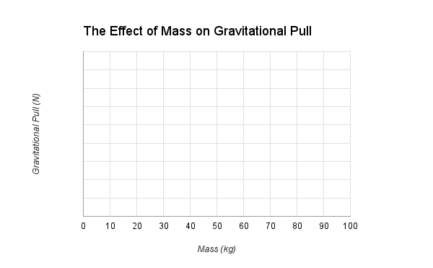
 | Summarize this graph in one sentence.

Part 2: Distance
Independent Variable  What will you change? | Distance between the objects
Dependent Variable
What will you measure?
Constants
What must be kept the same?

Data: | Change the distance and record the gravitational pull. You can leave off the zeros at the beginning and the decimal point. (For example 0.000000011256 can be just 11256.)  Distance (m) Gravitational Pull (N) Distance (m) Gravitational Pull (N)  10 5  9 4  8 3  7 2  6 1

Analysis | Make a graph of your data. Don’t forget to insert values along the y-axis for gravitational pull.
 | 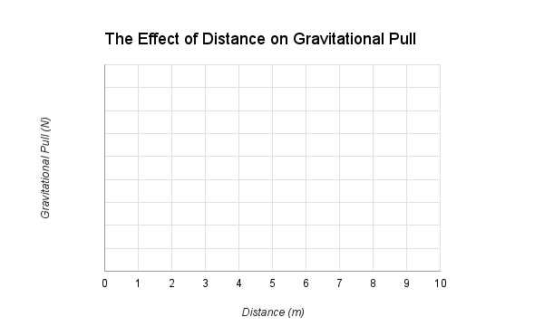
 | Summarize this graph in one sentence.

Conclusion | Write a conclusion that answers these two questions:  -How does the mass of an object change the gravitational pull on two objects in a system?  -How does the distance between objects in a system change the gravitational pull on them?  Make sure you use evidence from your experiment to support your claim.

