Name:_______________________
Period: ______________________
Learning Objective: Students will calculate speed, distance & time. Students will use diagrams, graphs and data tables to explain motion of objects.

Part 1: The Problem
Bob wants to go from CMS to TJ Maxx to buy a suit. What time will Bob have to leave CMS to arrive at TJ Maxx by opening time (10:00 am). He only has use of his tiny car. Conduct research and design an investigation to help Bob get to TJ MAXX.

Your group will have to find:
- Distance from CMS to TJ MAXX (miles)
- The average speed of Bob’s car. (feet per second)
- How long it will take Bob to get to TJ Maxx. (minutes)

Part 2: Collecting Data

Data Table 1: Distance from CMS to TJ MAXX

Distance (miles) | Research Source Used

Procedure: Average speed of Bob’s tiny car. List the steps you will follow and tools you will use to find out how fast Bob’s Tiny car can go.
1.
2.
3.
4.
5.
6.

Data Table 2: Average Speed of Bob’s tiny car. (feet per second) Only use the columns you need to in the data table. Label the columns!

Data Table 3: How long will it take for BOB to get to TJ MAXX?

Calculate the average speed of the tiny car.
(ft/sec)

Convert the distance from Cedar Middle School to TJ Maxx from miles to the units used in your average speed.
5,280 ft = 1 mile

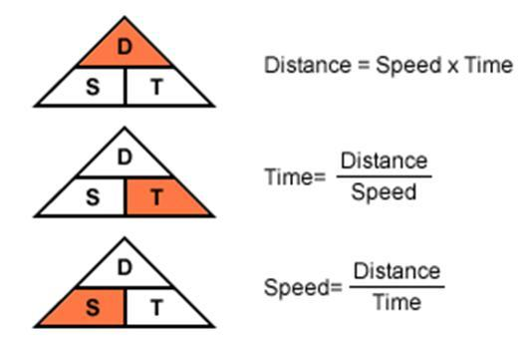
Calculate the time it will take Bob to get from CMS to TJ Maxx.]

Part 3: Applying Newton’s 3 Laws of Motion:
Explain how each Law of Motion was used or applied in this project.

#1 Law of Inertia:
________________________________________________________________________________________
________________________________________________________________________________________
________________________________________________________________________________________

#2 Law of Acceleration:
________________________________________________________________________________________
________________________________________________________________________________________
________________________________________________________________________________________

#3 Law of Action & Reaction:
________________________________________________________________________________________
________________________________________________________________________________________
________________________________________________________________________________________

