NAME ________________________ 5
MASS VS. WEIGHT
DATE ____________ PER ______

1. Why does the moon have less gravity than Earth? Use evidence to support your answer.

2. Fill in the blanks for each prediction with one of these words: stronger than, weaker than, or equal to. | 3. Go to the website: https://www.exploratorium.edu/ronh/weight/  Enter your weight at 100 pounds and test your prediction. Were your predictions correct? Why or why not?
The gravity on Jupiter is ___________________ the gravity than Earth.
The gravity on the sun is ___________________ the gravity than Earth.
The gravity on Pluto is ___________________ the gravity than Earth.

4. What have you learned about gravity so far? Include the word MASS in your answer.

5. Collect data on three different objects. Record your measurements in the table below.
MAKE SURE YOU INCLUDE THE MEASUREMENT UNITS!
Name of Object | Electronic Scale | Spring Scale | Triple Beam Balance
1
2
3

6. What observations can you make after completing the measurements above?

7. In your group discuss and fill out the table below.
Types of Scale | 1. What property does it measure? 2. What units does it use?  3. How does it work?
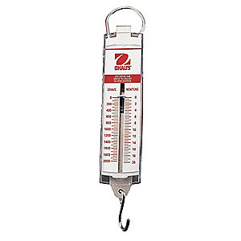  Spring Scale | 1.  2.  3. It works by gravity pulling on the mass of the object and stretching the spring.
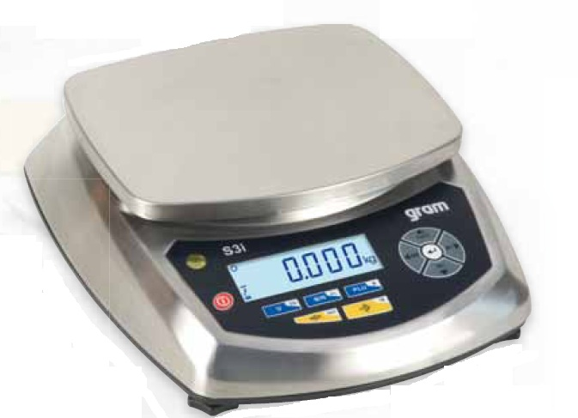  Electronic Scale | 1.  2.  3. It works by using weight to calculate the mass.
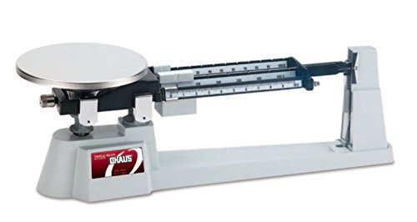  Triple Beam Balance | 1.  2.  3. It works by comparing it to another objects mass (the sliders on the beam)

8. Which of the 3 scales would read the SAME on a different planet? Why?

9. In your group discuss and full out the table below. Be prepared to share.

Science Terms
 | Measure of… | Measured in (units)… | Changes when…
Mass |  | Grams (g)  or  kilograms (kg)
Weight | How much gravity pulls on an object.
Gravity |  |  | Change the mass of the object. OR Change the distance between the objects.

10. Calculate your weight and mass on the moon, Jupiter, the sun, in space.

 | What is your weight on… | What is your mass on…
The Earth
The Moon
The moon’s gravity is 6x’s weaker than it is on Earth.
Jupiter
Jupiter’s gravity is 2.5x’s greater than it is on Earth.
The Sun
The Sun’s gravity is 28x’s stronger than it is on Earth.
In Space
There is little to no gravity in space.

11. Using evidence, explain the difference between Mass and Weight.

