NAME _________________________________4
DATE _____________ PERIOD ____________
CCC #1: PATTERNS

1. Stop and look around, you will notice that there are patterns everywhere. Many of these patterns may be part of a design on clothing, a building structure, or room decorations.
Discuss and share ideas of patterns with your group members. List your 3 favorite patterns.
1
2
3

2. In the world of science, observable patterns can help us understand the natural world and the development of explanations, models, and theories.
As a group, discuss and fill in the blank spaces below.
Pattern in Nature | How does this pattern help scientists to explain and understand the natural world?
1. Example: Repeating phases of the moon

2.

3. Pattern Practice: Fill in the blank spaces below.
Example | Is it a Pattern?  Yes or No | If yes, explain how this pattern helps scientists to better understand the natural world.
Arrangement of ice crystals in a snowflake
Random series of events

Group of flowers all blooming in harmony
An unpredictable asteroid approaching Earth
Spring, Summer, Fall, Winter...
An unexpected drought in April
PATTERN ACTIVITY
WHAT DO YOU ALWAYS HAVE BUT ALWAYS LEAVE BEHIND???
Materials: pencil, paper, tape, index finger
Instructions:
1.Use a pencil to scribble on a piece of paper until you have a nice black mark.
2. Rub your index finger in the black mark until the end of your finger is grayish/black.
3. Obtain 2 to 3 inches of tape and press it onto your black covered index finger.
4. Carefully remove the tape and place it at the bottom of this paper.

1. Describe what you see in your fingerprint? Is there a PATTERN in your fingerprint? ___________________________________________________
_____________________________________________________________

2. Compare your fingerprint with your
group members. Draw the general
shape of each of your fingerprints in
the boxes.

3. How are fingerprints classified or categorized?
_____________________________________________________________
_____________________________________________________________

4. Explain how observing and identifying patterns in fingerprints may be helpful.
_____________________________________________________________
_____________________________________________________________
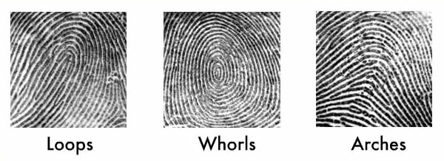
Stick tape with your finger print below.

