NAME__________________4
DATE__________PER_____
How do we know about layers deep within the Earth???
A. Go to the following website: http://bit.ly/atmjAB
B. Find the Key Code box in the upper left corner. Type in ES0402
C. You should now be at “A View from Above”
As a Class…
- What processes or events do we observe on Earth’s surface that tells us something about the inside of our planet?
Process or Event | What does this tell us?
1
2
3

Step 3
3. What are the 2 types of seismic waves that travels through the Earth when
an earthquake occurs?

4. What do seismometers track?

5. What has observations and analysis of the seismic waves led geologists to
infer?

6. What types of material do P waves pass through?

7. What types of material do S waves pass through?

Step 4
8. a. Which wave travels through both solids and liquids?

b. Which wave only travels through solids?

c. What does this difference tell scientists about the Earth’s interior?

9. a. Which wave travels faster than the other?

b. Which wave travels faster through solids?

c. What does the difference in the amount of time it takes for P and S
waves to travel through Earth’s interior tell scientists?

10. Based on the pattern of the P and S waves, what type of material is this
sample planet made of?

Step 5
11. Observe the path taken by P and S waves
in the model planet. Sketch the layers on
your diagram and indicate if they are solid
or liquid

Step 6
12. Observe the path taken by P and S waves
in the model planet. Sketch the layers on
your diagram and indicate if they are solid
or liquid.

Step 8
13. Observe the paths taken by P and S waves
through Earth. Sketch the layers on your
diagram and indicate if they are solid or
liquid.

Have you ever dug a hole in your backyard, or in the playground? How deep were you able to dig? 1 foot? 2 feet? Or perhaps you really worked hard, and were able to dig a hole that was 3 feet deep.

What would you need, if you wanted to dig a really deep hole? You could use a shovel, but eventually it would become too difficult. As the hole became deeper, you would need a way to remove the dirt as you loosened it. Otherwise you would not be able to throw the dirt out of the hole.

As your hole became deeper, you would quickly dig through the soft regolith or dirt, and begin hitting your shovel against hard bedrock. In order to continue digging, you would need a jack hammer, or drill to break through.

Suppose that you had all of this equipment available to you, how deep could you dig? The deepest mines on Earth are only about 2.5 miles deep. Some geologists have used massive drilling equipment to take narrow core samples from as deep as seven miles beneath the surface of the Earth.

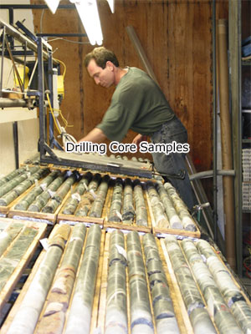
This seems like a very deep hole, but when compared to the overall radius, of the Earth, it is just scratching the surface. The Earth is approximately 4,000 miles (6,400 kilometers) from surface to center.

If scientists have never studied any materials from a depth below 7 miles, then how is it that we know what is in the center of the Earth? How can we know what the core of the Earth is made of, if we have never seen it?

The answer is actually quite simple. While it is true that we can not study the Earth’s core using visible light, we can study it using other senses. The most important thing we use to sense the Earth’s core are seismic waves. Seismic waves are waves of energy caused either by earthquakes, or by massive manmade explosions.
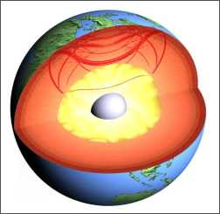

Seismic waves help scientists study the Earth's interior.

Scientists are able to measure these waves as they pass through the Earth. As these waves encounter different materials, they change in important ways, becoming longer, shorter, faster, or slower. Geologists study these changes in the waves, and are able to draw conclusions about what the core of the Earth must look like.

Geologists also can learn a lot about the core of our planet by looking at Earth’s magnetic field. The Magnetic field is created by massive circulations of hot liquid mantel beneath the Earth’s surface.

The Earth's magnetic field
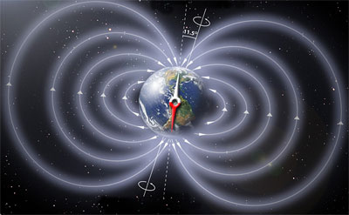

These clues lead geologists to believe that the Earth is made of four distinct layers. These layers are the crust, the mantel, the outer core, and the inner core.

Seismology
How do we know this is what the Earth looks like inside?

Different kinds of seismic waves are caused by Earthquakes in the crust:

* P-waves: compression (pressure) waves that pass through both solid and molten parts
* S-waves: shearing waves that can pass through solid parts, but are reflected/absorbed by molten parts.

In addition, there are surface waves that roll along the surface.

Seismologists use P- and S-waves from earthquakes to map the interior of the Earth like a doctor uses MRI or ultrasound to map the inside of a person.

Ever wonder how we know what the inside of the Earth is like? You were told in school that the inner core is solid iron and nickel, the outer core was liquid iron and nickel, the mantle was partially melted rock, and
the crust was solid rock. Did you just accept this and move on? Or did you wonder, "How do they know that? If they can't drill that far, aren't they just guessing?" No, scientists are not guessing. Here is the science explained. The science teacher is in the house.

Scientists have determined what the interior of the earth is like through analyzing seismic or earthquake waves. When earthquakes occur, there are three different types of waves that are sent out from the focus of the earthquake: an p-wave, an s-wave, and an 1-wave. A p-wave is a compression wave that travels down through the earth. Picture a slinky. If you were to show a p-wave using a slinky, you would stretch out the slinky and push the slinky in so that the springs would be getting closer together and farther apart. P -waves can travel through solids and liquids. They are the fastest moving earthquake wave. When the p wave enters a rock of greater density, it speeds up; when it enters a rock of lower density (or liquid) it slows down.

An s-wave is a shear wave. It also travels through the earth's interior. Picture the slinky again. If you were demonstrating a s-wave using a slinky, wave the slinky up and down so that you would create a typical wave. S-waves are slower moving than a p-wave, but also more destructive earthquake waves. S-waves only travel through solids.

An l -wave is a surface wave which, as the name suggests, travels on the surface of the earth. These are the earthquake waves that we think of when earthquakes occur. Picture that slinky one more time. If you were to demonstrate an l-wave with a slinky, you would move it like a jump rope. It moves out from the epicenter of the earthquake like a ripple on a pond. L-waves are earthquake waves that travel through solids, liquids, and gases (that is why you can hear a rumble during an earthquake).

Page:
12Next Page »

When an earthquake occurs, seismic stations all over the world are receiving the earthquake wave data. They are detecting the p-waves, s-waves and l- waves. Although faint, seismic stations thousands of miles away are
able to detect these waves. However, when studying these waves, scientists noticed a "shadow zone" where s-waves were not able to be detected after an earthquake (see picture). The p-waves and l-waves would be detected at the seismic station, but the s-waves would not be detected. Scientists deduced that, because s-waves cannot travel through liquids, a section of the earth's interior must be liquid as well. Performing some simple mathematics on the size of the s - wave shadow zone and the diameter of the earth, scientists were able to tell exactly where and how big that liquid area was, without seeing it.

The scientists had also noticed that, after an earthquake, the p-waves would not follow a straight line when they were traveling through the earth. They would bend or refract, as the traveled through the earth, as indicated by the seismic stations. This refraction of earthquake waves is due to the fact that the waves slow down or speed up when entering a medium of a different density. By following the waves' path, they were able to determine the density of the material that the wave traveled through, and therefore able to tell if the layer was solid, liquid, or partially melted. Through these techniques and the indication that our earth has a magnetic field, scientists were able to determine the composition and nature of the interior of earth, without having ever been there.

http://www.classzone.com/books/earth_science/terc/navigation/using_ee.cfm

