How does Density affect the Layering of the Earth?

Density
a. Determines the way materials in a mixture are sorted.
b. This results in the layering and structure of Earth’s
atmosphere, water, crust, and interior.
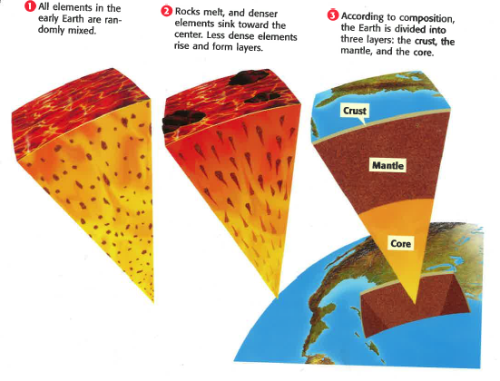

Earth
1. Scientists explain that today’s Earth formed from a very hot
MOLTEN ball of liquid!
2. As the Earth cooled denser materials could move, based on
their densities!
3. Therefore, Earth is structured around the density of the
materials which make it up.

SciberText
How Do The Densities of Earth’s Layers Compare?
What is the order of the 4 pictures from least dense to most dense?
(B) Air & Clouds (A) Igneous Rock (Lava)
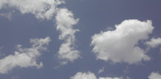
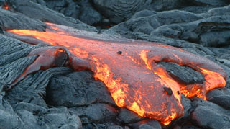

(C) Water (Ocean) (D) Rocks & Soil
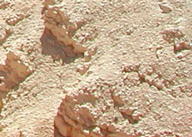
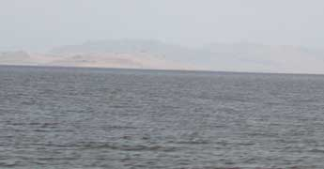

Sciber Text
Lets Build The Earth (Acting the Earth’s Parts)
Pass out cards with assignments!

Each person who is "acting out" the part of the interior is to flex his or her muscles or pretend to lift weights. Each of these people is to stand in the center of the activity area. These people represent the core, which is the most dense part of Earth.

Individuals who are "acting out" the crust are to form a circle around the core. This group of people is to then chant, "rock, rock, rock" in unison.

People who "act out" the part of water are to surround the crust. (There may be gaps between each of these individuals.) These people are to sway their bodies back and forth to represent the movement that occurs in this less dense layer.

Finally, each person who is "acting" as the atmosphere are to form a circle around at a large distance away from the water. Each of these people is to face away from the rest of the group. These people are to slowly walk around the rest of the Earth. This movement represents air currents which are present in the atmosphere.

CORE  Each person who is "acting out" the part of the interior is to flex his or her muscles or pretend to lift weights. Each of these people is to stand in the center of the activity area. These people represent the core, which is the most dense part of Earth. | CRUST  Individuals who are "acting out" the crust are to form a circle around the core. This group of people is to then chant, "rock, rock, rock" in unison.
WATER  People who "act out" the part of water are to surround the crust. (There may be gaps between each of these individuals.) These people are to sway their bodies back and forth to represent the movement that occurs in this less dense layer. | ATMOSPHERE (AIR)  Finally, each person who is "acting" as the atmosphere are to form a circle around at a large distance away from the water. Each of these people is to face away from the rest of the group. These people are to slowly walk around the rest of the Earth. This movement represents air currents which are present in the atmosphere.

NAME________________3
DATE_______PER______
How does Density affect the layering of Earth?
STUDY GUIDE!

- What determines the way materials are sorted in a mixture?
BIG DADDY D or _______________!!!

- Density also determines the layering and structure of Earth’s atmosphere, water, ___________, mantle and ____________.

- What do scientists say formed from a very hot MOLTEN ball of liquid rock?

- As the Earth cooled and hardened, how did materials move?

- Therefore, ________________ is structured around the density of the materials which make it up!

- What is the order of the 4 pictures from least to most dense? Write the letter & name of picture.

B
Atmosphere
C
Water/Ocean
A
Mantle/Core

Least dense ____________________________
_____________________________
_____________________________
Most dense _____________________________

D
Crust

7. Draw dots to represent how tightly packed each layer’s particles would be.

- Which of the following particles would best represent the 5 layers? There are multiple answers possible.
Material | Density (g/cm³)
Cotton | 1.50
Plastic Wrap | 0.95
Cardboard | 0.69
Paper | 1.20
Aluminum Foil | 2.70
Copper Penny | 8.3 – 9.0
Steel | 8.3
Rubber | 1.40
Glass (marble) | 2.60
Plastic Egg | 0.90
Coffee Filter | 0.20
Iron Ball | 12.0

Earth Layer | Actual Density | Material used to represent layer | Density of Material
Atmosphere | 0.0013
Water | 1.0
Crust | 3.0
Mantle | 4.5
Inner & Outer Core | 10 – 14.5

