Name_____________________________2
Natural Selection

Date __________________Per__________

1. Go to the following website:

http://sciencenetlinks.com/interactives/evolution.html

Click “How to Play” on the bottom left. Read the instructions and answer

the following questions:

A. What predators eat the bugs?

B. How do the predators choose which bug to eat?

Click on “Back” and watch the simulation for 1 minute. C. Which color of bug was eaten the most? WHY?

Adjust the color and watch the simulation for 1 minute again. D. Which color of bug was eaten the most? Why?

E. What environmental change occurred?

How did it affect the green bug population?

How did it affect the orange bug population?

2. Explain what NATURAL SELECTION is using evidence from the bug simulation.

3 Sentences minimum!

___________________________________________________________________

___________________________________________________________________

___________________________________________________________________

___________________________________________________________________

Referring to Mrs. Allred’s Natural Selection ppt…

3. Why did the BLOBS species population with the long, pointed noses

increase? What is this an example of? Explain using evidence!

3 Sentences minimum!

___________________________________________________________________

___________________________________________________________________

___________________________________________________________________

___________________________________________________________________

Natural Selection or Selective Breeding?

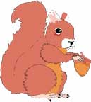
1 Squirrels of the Grand Canyon:
Originally, there was only one species of squirrel living in the Grand Canyon.
As the Grand Canyon deepened and widened, the group of squirrels on the north side of the canyon got separated from the group on the south side. The squirrels separated on the north side now have black fur which matches the rich dark soil, while the squirrels on the south side have red fur which matches the sandy soil. The separation of the two groups caused them to evolve different traits. The two groups are becoming more and more genetically different, and in time will likely become two different species.
Natural Selection or Selective Breeding? Explain using Evidence: ___________________
___________________________________________________________________________
_________________________________________________________________________________

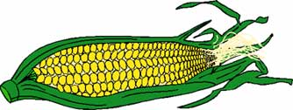
2 Corn:
People have been selectively breeding plants and animals for a
long time. Native Americans produced corn by selectively
breeding a species of weed. The corn they produced had ears that
were only three inches long. Modern science has increased the length of the ears to one foot in length.
Natural Selection or Selective Breeding? Explain using Evidence: ___________________
___________________________________________________________________________
_________________________________________________________________________________

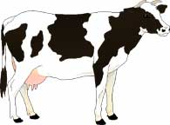
3 Cows:
Farmers practice Selective Breeding by crossing cows
with traits that produce the most milk or meat.

Natural Selection or Selective Breeding? Explain using Evidence: ___________________
___________________________________________________________________________
_________________________________________________________________________________

4 Finches on the Galapagos Islands:
As Charles Darwin conducted research on the Galapagos Islands, he
noticed differences in the Finch birds from island to island. One of the
biggest differences were the sizes and shapes of the birds’ beaks. Each
bird had the type of beak it needed to survive. Finches that ate insects
had sharp needlelike beaks. Those that ate seeds had strong, wide beaks.
The shape of the beak is an example of an adaptation, or change over time, that helped the birds survive.
Natural Selection or Selective Breeding? Explain using Evidence: ___________________
___________________________________________________________________________
_________________________________________________________________________________

