NAME ___________________________12
DATE________________ PER__________
DIFFUSION

1. ___________________ is the movement of particles from an area of high concentration to an area of low concentration.

___________ ___________

2. Which diagram accurately shows diffusion? And WHY????

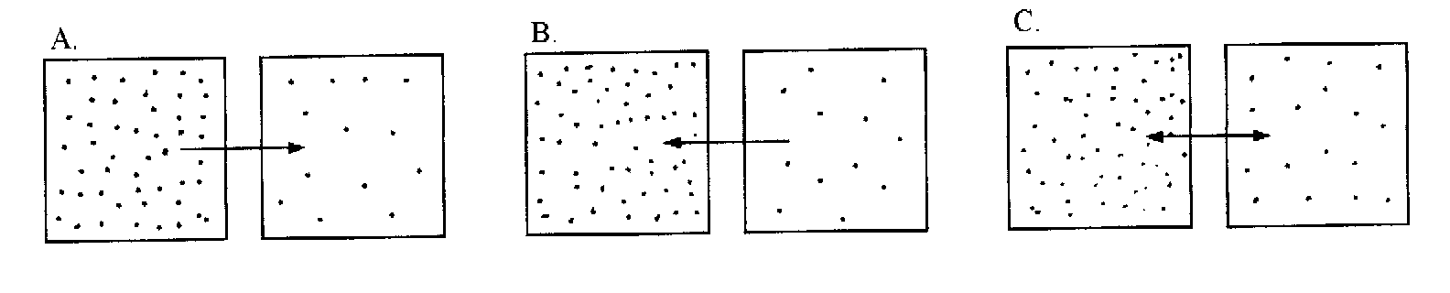

WHY? ____________________________________________
_________________________________________________
_________________________________________________

3. List and explain 3 examples of diffusion.

1. ___________________________________________
___________________________________________
___________________________________________

2. ___________________________________________
___________________________________________
___________________________________________

3. ___________________________________________
___________________________________________
___________________________________________

