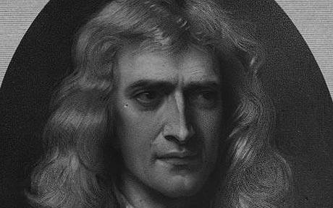
name:_______________________ 1
Learning Objective: Students will identify the forces acting on a moving object, determine the direction an object will move when one or more forces are applied, understand that motion can be described mathematically and that motion is governed by scientific laws, most commonly called Newton’s Laws of Motion.

period: _________________

I. NEWTON’S FIRST LAW OF MOTION: http://teachertech.rice.edu/Participants/louviere/Newton/law1.html (20 points possible)

- Newton’s first law of motion is also known as the LAW OF ______________________________________.

- Newton’s first law says that
- an object that IS NOT MOVING, or is at ___________________________, will stay at ___________________, AND
- an object that IS MOVING will keep moving with constant __________________________, which means at the same _____________________ and in the same ________________________, UNLESS
- an ______________________________ force acts on that object.

- What is inertia?

- What property of an object determines how much inertia it has?

- Which of the following has more inertia?
  - Bowling ball or Tennis ball
  - Hammer or Feather

II. NEWTON’S SECOND LAW OF MOTION: http://teachertech.rice.edu/Participants/louviere/Newton/law2.html

- Newton’s second law of motion is also known as the LAW OF ______________________________________.

- Newton’s second law says that when an __________________ force is applied to a ________________, it causes it to ____________________________.
- The greater the force that is applied, the ____________________ the acceleration.
- The lesser the force that is applied, the _____________________ the acceleration.
- If the same force is applied to an object with a large mass, it will have a _______________________ acceleration.
- If the same force is applied to an object with a small mass, it will have a _______________________ acceleration.
- The equation that is used to solve second law problems is F = ma.
  - What do each of the variables mean?
F = ______________________ m = _________________________ a = __________________________
  - What unit of measurement must be used with each variable?
F = ______________________ m = _________________________ a = __________________________
- Solve these problems:

  - Your bike gets a flat tire. Its mass is 10 kg and you are able to accelerate your bike .5 m/s/s. What is the force on the bike?

  - You have a mass of 50 kg and accelerate toward Earth at a rate of approximately 10 m/s/s. What is your weight (force of gravity)?

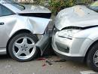
14.
20 N
150 N
100 N
15 N

Which direction will the ball go? Which car would’ve been pushed in the opposite direction?

III. NEWTON’S THIRD LAW OF MOTION: http://teachertech.rice.edu/Participants/louviere/Newton/law3.html
- Newton’s third law of motion is also known as the LAW OF _______________________________________________.
- Newton’s third law says that every time there is an ______________________________ force, there is also a _______________________ force that is ______________________ in size and acts in the ____________________________ direction.
- Newton’s third law states that forces must ALWAYS occur in ___________________________.
- Listed below are ACTION forces. Tell the REACTION force.
  - Your bottom pushing on your desk seat
  - A bat hitting a baseball
  - Your finger pressing on your phone screen while texting
IV. UNDERSTANDING….. (20 point possible)
Label each of the following images/descriptions below as being examples of 1st, 2nd, or 3rd law. EXPLAIN your answer!
1st law 2nd law 3rd law
Explanation: ____________________________________________________________________________________________________________________________________________________________________________________________________________________________

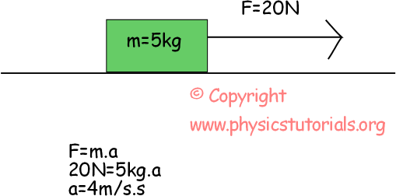

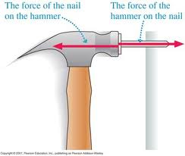
1st law 2nd law 3rd law
Explanation: ____________________________________________________________________________________________________________________________________________________________________________________________________________________________

1st law 2nd law 3rd law
Explanation: ____________________________________________________________________________________________________________________________________________________________________________________________________________________________

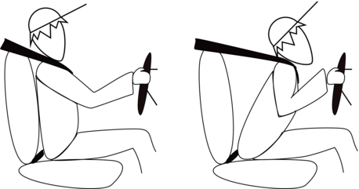

1st law 2nd law 3rd law
Explanation: ____________________________________________________________________________________________________________________________________________________________________________________________________________________________

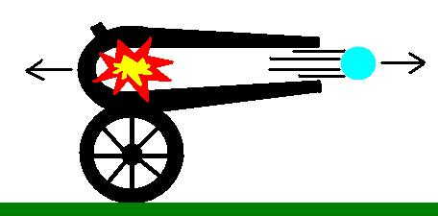
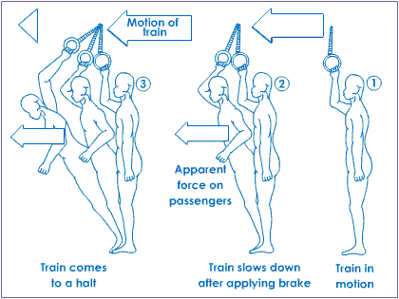
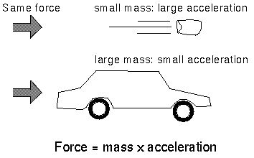
1st law 2nd law 3rd law
Explanation: ____________________________________________________________________________________________________________________________________________________________________________________________________________________________

1st law 2nd law 3rd law
Explanation: ____________________________________________________________________________________________________________________________________________________________________________________________________________________________

Newton's laws of motion
From Wikipedia, the free encyclopedia
Isaac Newton (1642-1727), the father of the study of dynamics, – the study of motion – developed three sets of laws that are believed to be true because the results of tests done by scientists agree with the laws he produced.

First Law
If a body is at rest it remains at rest or if it is in motion it moves with uniform velocity until it is acted on by a resultant force. (Duncan Falconer, 1995)
In other words, the first law says that an object that is not moving or moving with constant velocity will stay like that until something pushes it or blocks its path. From everyday experience we might complain that objects do not remain without motion (for example, a ball held above the ground does not stay there if it is released), nor do they remain in motion with a constant speed (a ball rolling down a hill moves faster and faster, while a ball rolling along a flat surface will eventually stop moving); however, if we were to remove external forces such as gravity and friction, we would observe the first law of motion.

Second Law
Force is equal to mass times acceleration
This law provides the definition and calculation of force through mass and acceleration.
For example, Weight is a force that we feel on Earth, caused by the gravity. Weight is calculated as
where m is the mass of the object and g is the local gravitational acceleration (not to be confused with G, the universal gravitational constant), roughly equal to 9.8 meters per second² (32 feet per second²) on Earth.

Third Law
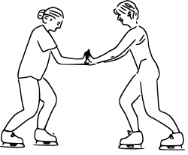
Newton's third law. The skaters' forces on each other are equal in magnitude, and in opposite directions
Continued on the next page…

For every action, there is an equal and opposite reaction.
The statement means that in every interaction, there is a pair of forces acting on the two interacting objects. The size of the forces on the first object equals the size of the force on the second object. The direction of the force on the first object is opposite to the direction of the force on the second object. Forces always come in pairs - equal and opposite action-reaction force pairs.
A variety of action-reaction force pairs are evident in nature. Consider the propulsion of a fish through the water. A fish uses its fins to push water backwards. But a push on the water will only serve to accelerate the water. Since forces result from mutual interactions, the water must also be pushing the fish forwards, propelling the fish through the water. The size of the force on the water equals the size of the force on the fish; the direction of the force on the water (backwards) is opposite the direction of the force on the fish (forwards). For every action, there is an equal (in size) and opposite (in direction) reaction force. Action-reaction force pairs make it possible for fish to swim.
Consider the flying motion of birds. A bird flies by use of its wings. The wings of a bird push air downwards. Since forces result from mutual interactions, the air must also be pushing the bird upwards. The size of the force on the air equals the size of the force on the bird; the direction of the force on the air (downwards) is opposite the direction of the force on the bird (upwards). For every action, there is an equal (in size) and opposite (in direction) reaction. Action-reaction force pairs make it possible for birds to fly.
Consider the motion of a car on the way to school. A car is equipped with wheels which spin backwards. As the wheels spin backwards, they grip the road and push the road backwards. Since forces result from mutual interactions, the road must also be pushing the wheels forward. The size of the force on the road equals the size of the force on the wheels (or car); the direction of the force on the road (backwards) is opposite the direction of the force on the wheels (forwards). For every action, there is an equal (in size) and opposite (in direction) reaction. Action-reaction force pairs make it possible for cars to move along a roadway surface.
Summarize each of Newton’s Law using a minimun of 3 sentences. (30 points possible. 10 points for each summary)
Newton’s 1st Law: _________________________________________________________________________________________
________________________________________________________________________________________________________
________________________________________________________________________________________________________
________________________________________________________________________________________________________
Newton’s 2nd Law: ________________________________________________________________________________________
________________________________________________________________________________________________________
________________________________________________________________________________________________________
________________________________________________________________________________________________________
________________________________________________________________________________________________________
Newton’s 3rd Law: ________________________________________________________________________________________
________________________________________________________________________________________________________
________________________________________________________________________________________________________
________________________________________________________________________________________________________
________________________________________________________________________________________________________

