NAME _____________________1
DATE ____________ PER _______
MAGNETIC INVESTIGATION
Magic or Magnetic  1. Hold a stack of 4 round magnets under the table and 1 round magnet on top of the table. Slowly move the 4 magnets around under the table.  Explain what happened to the single magnet on top of the table and WHY???  ___________________________________  ___________________________________  ___________________________________  2. Explore with the petri dish full of iron fillings. Place two round magnets on the bottom and two on the top. Flip the top magnets over. Explain what happens to the iron filings.  ___________________________________  ___________________________________ | Magnet vs Compass  1. Practice and Observe how the compass works.  2. Place a magnet next to the compass (without touching the compass and magnet)  What is the effect? Explain!  ___________________________________  ___________________________________  ___________________________________  3. If the needle of the compass moves with the magnet, what do you know about the needle?
Magnetic Field using a Compass  1. Place a compass in different locations around a bar magnet. Draw an arrow showing the direction the compass needle points (RED end of the needle).  2. What do the arrows represent around the magnet? ________________________________ | Magnetic Field Investigation  1. Using two bar magnets, move one magnet with the other magnet (WITHOUT ALLOWING THEM TO TOUCH).  Explain WHAT allowed you to accomplished this.  ___________________________________  ___________________________________  SEE MRS. A FOR THIS ONE  2. Place a sheet of wax paper over a bar magnet. Carefully sprinkle iron fillings over the wax paper and observe the pattern they form.  Draw the pattern formed by the iron filings.

Question: Do forces exist between objects that do not physically touch? Explain using EVIDENCE!! ___________________________________________________________________
_____________________________________________________________________________
_____________________________________________________________________________

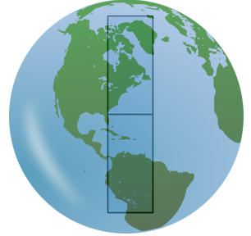1. Imagine there is a bar magnet in the center of the earth
that generates Earth’s magnetic field. Label the bar magnet
inside the earth with an N and an S where you think the
north and south magnetic poles are.

2. Use the PHET “Compass and Magnet” simulation. Leave all of the settings on the right-hand side of the screen exactly as they are. Move the compass, not the bar magnet. The red end of the compass needle is the north end.
a. As you move the compass around the magnet, does the red end always point north?
b. What causes this to happen?
c. Move the compass around the magnet again. Which end of the magnet does the red end point at most of the time? Which end does it point away from?
d. When are two magnets attracted?
e. Apply this information to the simulation. What causes the compass needle to point the way it does?

3.
Click on the button that says Show Planet Earth. Draw a model of Earth’s magnetic field. Label the bar magnet inside the earth. Make sure you draw arrows on the magnetic field lines showing the direction of the magnetic forces.

