NAME 12
DATE PERIOD .

Three Things that Affect the DENSITY of a Substance

1 Temperature: (fill in blanks with increase or decrease)
a. If temperature , particles expand, increasing volume, which density.
b. If temperature , particles contract, decreasing volume, which density!
c. DRAW AND LABEL a picture showing the blue (cold) and red (hot) water in the container after the divider was removed.

d. Explain why the hot and cold water have different densities.

2 Pressure: (fill in blanks with increase or decrease)

a. If pressure , particles contract and volume decreases, which density.
b. If pressure , particles expand and volume increases, which density.
c. Give an example of how pressure affects density.

3 Salinity:

a. Salinity is the amount of dissolved in water.
b. The greater the salinity, the dense the water.
c. The less the salinity, the dense the water.
d. Why do people float so easily in the Great Salt Lake?

e. What happened with the egg demonstration? Draw the egg in both the salt and fresh water.
Fresh With Salt
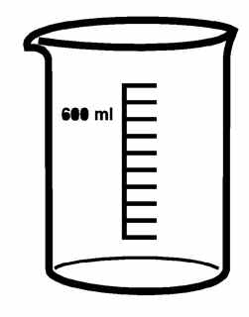

f. Explain why the egg would behave differently in fresh and salt water.

4. Why do hot air balloons rise?

5. Explain how lava lamps work?

