Stability and Change Name ___________________________ 10
Date _________________Per. __________

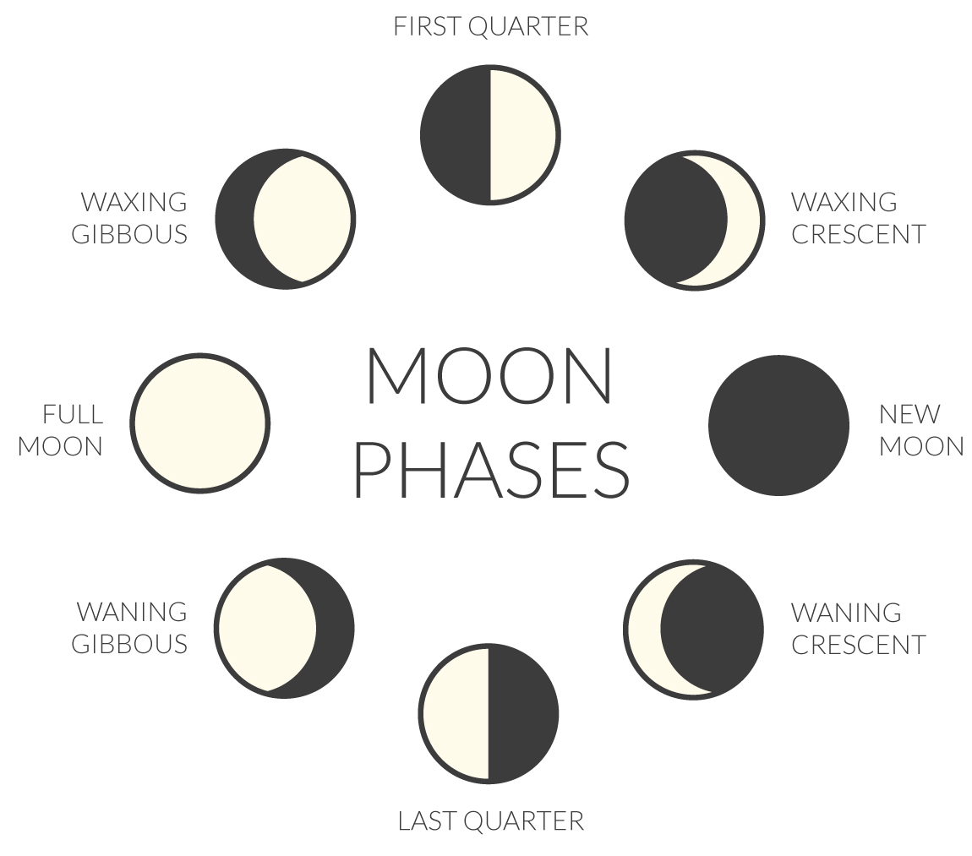
1. Explain how moon phases are an example of both STABILITY and CHANGE.

Stability:

Change:

2. Have you ever set up dominos and knocked the end domino down, causing all the dominos to fall down? With your group, set up the dominos in a line, approximately 1 inch apart. The line can be curved or straight. Tip the last domino over, toward the others and see what happens.

a. Once the “system” was set up, what was the initial change you made?
_________________________________________________________________________________________________________________
b. Did the initial change have any effect on the rest of the system? What?
_________________________________________________________________________________________________________________
c. There are cycles in nature that can be affected by even small changes. List an example in nature of one small change having an effect on a system.
________________________________________________________________________________________________________
3. Watch the Rube Goldberg video. Notice, before the initial change occurs, the “system” is stable and still remain the same until something starts the process.
List as many changes as you can that you saw in the Rube Goldberg.
__________________________________________________________________________________________________________________________________________________________________________________________________________________________________
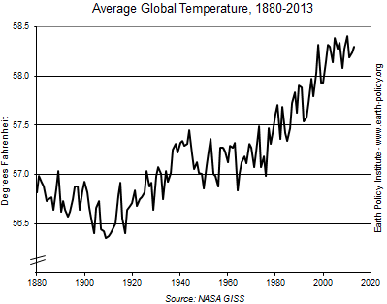
4. The Earth is a system. Scientists gather information about climate and weather to track any changes that might be occurring in that system. The following graph shows the average Earth temperature over time.
a. Does this system appear to be stable or changing?
Explain using Evidence _______________________________ __________________________________________________________ __________________________________________________________
__________________________________________________________ __________________________________________________________

Forest Eco-System
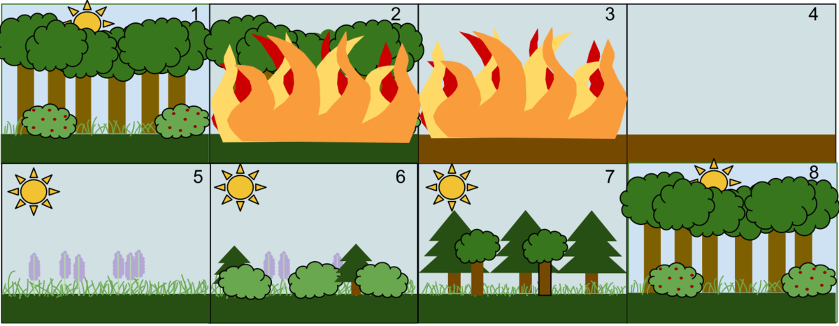

1. Briefly describe what is happening in each picture.
1. ____________________________________________________ 5. _____________________________________________________
2. ____________________________________________________ 6. _____________________________________________________
3. ____________________________________________________ 7. _____________________________________________________
4. ____________________________________________________ 8. _____________________________________________________

2. Explain in your own words how the Brianhead fire could be viewed as a POSITIVE AND a NEGATIVE change to the forest eco-system.
A. Positive: ___________________________________________________________________________________________________
________________________________________________________________________________________________________________
________________________________________________________________________________________________________________
B. Negative: ___________________________________________________________________________________________________
________________________________________________________________________________________________________________
________________________________________________________________________________________________________________

